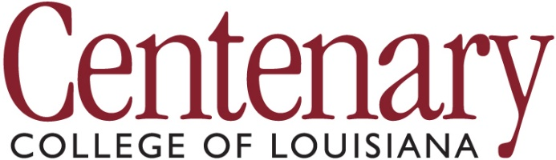
Institutional Review Board
Research Renewal
Involving Human Participants

Use this form if your project was previously approved by the IRB, but the project is continuing past the original approval expiration date.

Original Protocol #:
Most Recent Protocol Expiration Date:
Project Title:
Principal Investigator:
(for student projects)
Staff/Faculty Supervisor:
Research Collaborators
(individuals and/or institutions):
Date you began original data collection:
Date you expect to complete the project:
Do you need evidence of IRB approval for some outside agency?
If yes, what is the deadline?
Please explain why your protocol requires an extension.
Have any aspects of your recruitment, subject population, procedures changed from your original protocol? (If you need the IRB Chair to send you your original protocol, please ask.) If so, please explain.

When completed, please email (as attachments) to the Chair of the IRB the following documentation:
(Dr. Peter Zunick, pzunick@centenary.edu)
ü | this form
ü | your consent form(s)
ü | proof of completion of ethics training (NIH or CITI certificate) for all researchers collecting data for this project, or indicate that they have completed the Centenary ethics training on Canvas
ü | as relevant, any other documents seen by participants (e.g., recruitment posters, questionnaires, debriefing forms)

